**3. Spectral estimation and modelling**

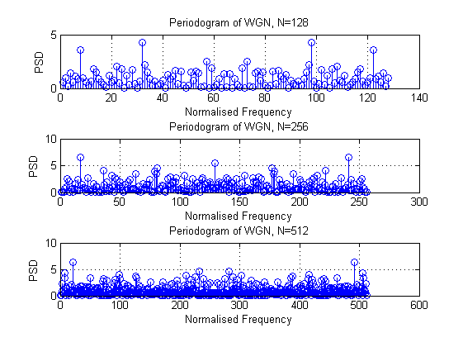

**Figure 1.** PSD estimation of WGN for N=128, 256,512

Figure 1 shows the PSD of WGN of various lengths. The theoretical PSD of WGN is a horizontal since all frequency components have same power magnitude. The above figure generally agree with theory. As sample number of WGN increases, a more accurate estimation of PSD is made. Power band is, hence, more flat over frequency axis.

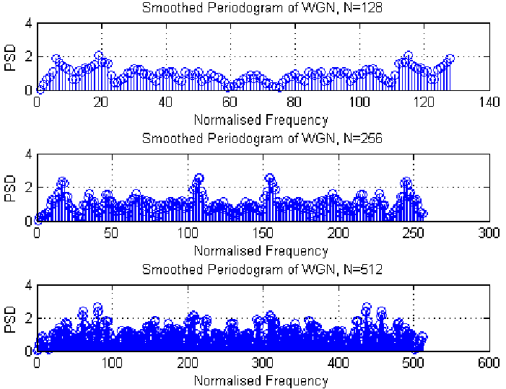**3.1 Averaged periodogram estimates**

**3.1.1**

**Figure 2.** SmoothedPSD estimation of WGN for N=128, 256,512

Figure 2 shows the smoothed PSD of WGN of various lengths. Compared to figure 1, figure 2 is more close to the theoretical graph of PSD, which is a flat band across all frequencies.

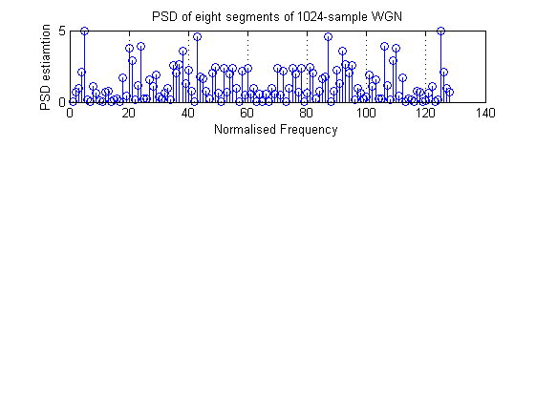**3.1.2**

**Figure 3.** Sample PSD of one segment of 1024-sample WGN

One of the eight segments of 1024-sample WGN. It is observed that this shape is similar to the PSD of 128 WGN samples shown in figure 1. As a result, the inaccuracy of this PSD estimation is caused by its limited sample length.

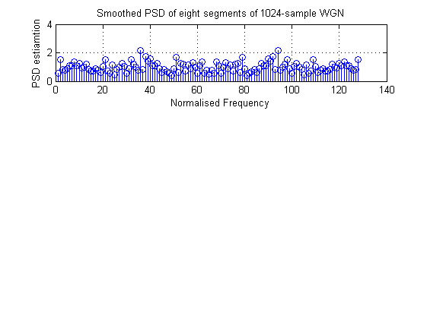**3.1.3**

**Figure 4.** Averaged periodogram of one segment of 1024-sample WGN

Figure 4 shows the smoothed PSD of the segment in Figure 3. Averaged periodogram is more close to the theoretical PSD compared to individual PSD. Each frequency bin of averaged periodogram is the mean of the PSD estimation of eight segments. As a result, their differences to theoretical value cancel out each other and a better prediction is, hence, obtained.

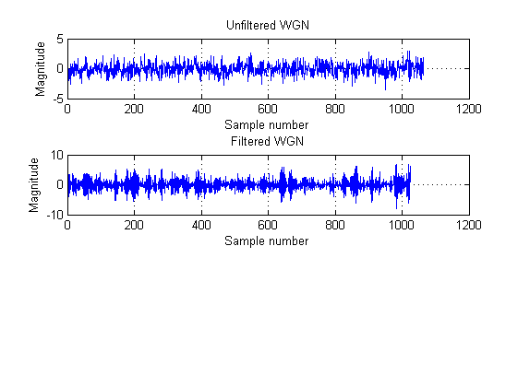**3.2 Spectrum of autoregressive processes**

**Figure 5.** Comparison between filtered and unfiltered WGN

It is observed from Figure 5 that filtered WGN varies faster than the unfiltered because the AR1 filter with a=[1 0.9] is equivalent to a high-pass filter with a pole at (-0.9,0). As a result, the low frequency components of WGN is filtered and noise looks varying faster.

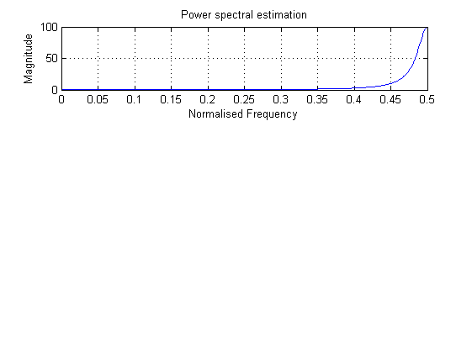**3.2.1**

**Figure 6.** Power spectrum estimation of the filter with pole at (-0.9, 0)

PSD of the filter is shown in figure 6. $H\left(z\right)=\frac{1}{1+0.9z^{-1}}$ is the filter transfer function. By substitute $z=e^{jw}$. We obtain $\frac{e^{jw}}{e^{jw}+0.9}$. Since $e^{jw}=cos⁡(w)+jsin(w)$, w is calculated to be 2.69 rad/s, corresponding to 0.43 in this graph. Since figure 6 is a power graph, our calculated result approximately matches theory.

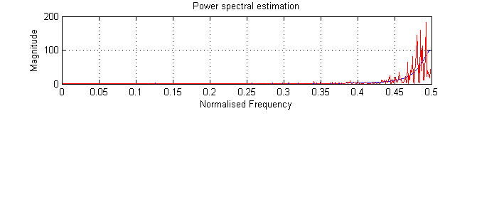**3.2.2**

**Figure 7.** PSD comparison between filter and filtered WGN signal

Figure 7 compares the theoretical filter power spectrum and actual power spectrum of output after passing WGN through the filter. Since the input sample is limited, input spectrum is not a flat band over all frequency, spectrum always fluctuated around the average. As a result, In the transition and pass-band of the filter, fluctuated spectrum is shown rather than a smooth high pass curve.

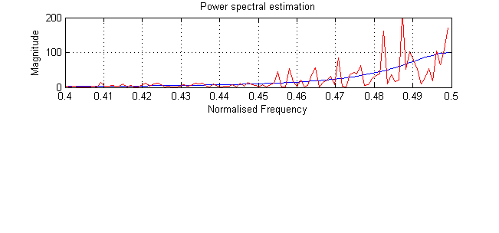**3.2.3**

**Figure 8.** PSD comparison between filter and filtered WGN signal

The pgm function written in before takes a finite length of input data, which can be considered as multiplying a complete white noise and a rectangular window. The effect is equivalent to convolution of the theoretical filter spectrum with a sinc function, which is centred in the middle of frequency spectrum, i.e. 0.5. As a result, spectrum fluctuation increases when normalised frequency is getting close to 0.5. The fluctuation due to windowing adds to the fluctuation caused by incomplete input data.

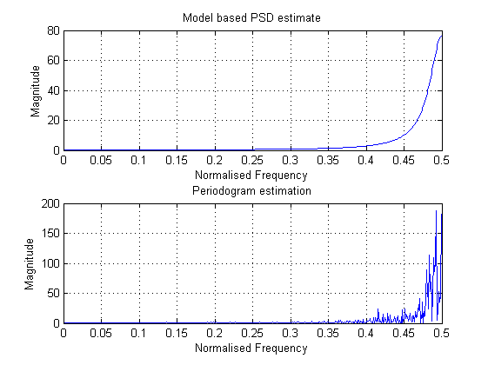**3.2.4**

**Figure 9.** PSD comparison between model based and periodogram estimate

Figure 9 shows the comparison between model based and periodogram estimate. It can be seen that two curves are similar but not exactly same. Periodogram estimate is less close to the theoretical value than model based estimation since it directly transfer signal from time domain to frequency domain using FFT. Also, note that the magnitude of periodogram is larger than that of model based estimation, since the magnitude of periodogram mostly depends on signal variance. Therefore, AR model based estimate provides good result in estimating peaks, but not exact amplitude.

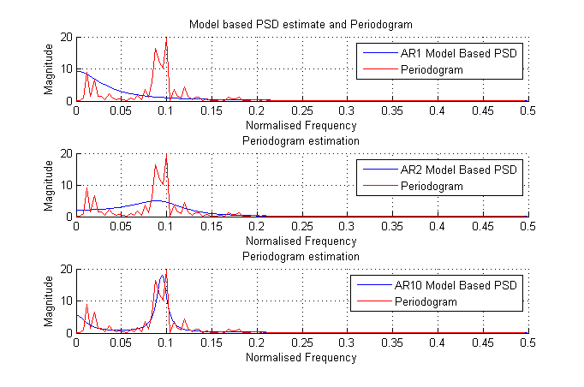**3.2.5**

**Figure 10.** PSD comparison between model based and periodogram estimate for order 1,2 and 10

Figure 10 compares the model based PSD and periodogram of sunspot for AR1, AR2 and AR10. As we increase AR model number, simulated result approaching to ideal PSD. Compared to zero mean data, PSD of non-zero mean data consists of mostly are low-frequency components, which makes the PSD difficult to observe.

**3.3 Spectrogram for time-frequency analysis: dial tone pad**

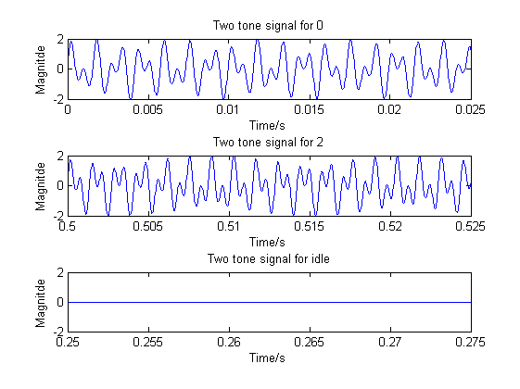**3.3.1**

**Figure 11.** Two-tone signals for DTMF system

Figure 11 shows the two-tone signals for digit 0, 2 and idle. From the formula of sine wave addition: $\sin\left(2π*a*n\right)+\sin\left(2π*b*n\right)=2sin⁡(2π*\frac{a+b}{2}*n)cos⁡(2π*\frac{a-b}{2}*n)$, $\frac{a+b}{2}$ is the frequency perceived by listener, while the other part $\frac{a-b}{2}$ controls the envelop of signal, and causes perception of ‘beats’. In this case maximum possible frequency required to represent is Sampling $\frac{1477+941}{2}=1209 Hz$. Frequency 32768 is an appropriate number. It is around 10 times of the minimum frequency to represent 1209 Hz and good enough to represent an accurate time domain wave. Higher sampling frequency provides more accurate results at the cost of extra cost in time and space complexity.

**3.3.2**

Figure 12 shows the spectrogram of randomly generated London landline number. In the graph, the generated number is: 020 1832 7006. It can be seen that frequency of each dual tone signal has two main peaks at expected normalised frequencies.

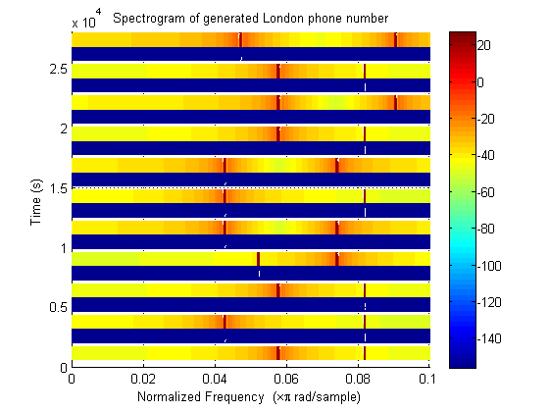

**Figure 12.** Spectrogram of landline 020 7121 0903

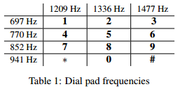**3.3.3**

Table 1 shows the actual frequencies representing each number. Converted to normalised frequency with sampling frequency 32768 Hz. The graph becomes:

**Table 2.** Dial pad normalised frequency with Fs=32768 Hz

|  |  |  |  |
| --- | --- | --- | --- |
|  | 0.073792 | 0.081543 | 0.090149 |
| 0.042542 | 1 | 2 | 3 |
| 0.046997 | 4 | 5 | 6 |
| 0.052002 | 7 | 8 | 9 |
| 0.057434 | * | 0 | # |

For example, the first node has frequency components at around 0.057 and 0.081, which corresponds to the number 0. Using the same rule we can derive that the number series is 020 4204 8592, which agrees with the input number sequence.

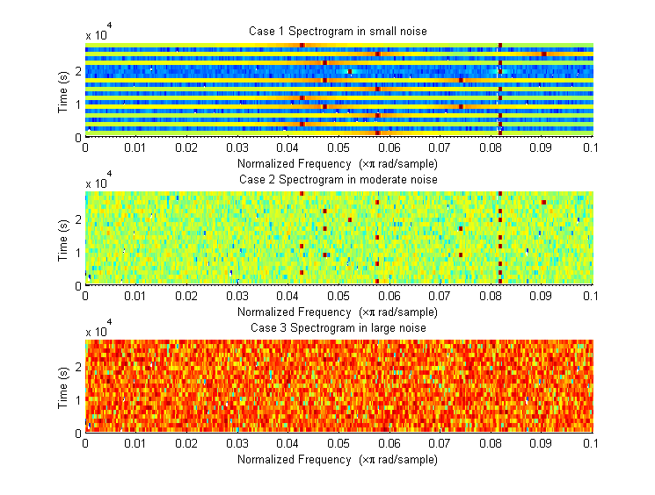

**3.2.4**

**Figure 13.** Spectrogram in various WGN

Figure 13 shows the spectrogram for various WGN amplitude. As we can see that, WGN introduces bins in all frequency regions. When the amplitude of WGN is small compared to signal, tone is still identifiable. When WGN has frequency amplitude larger than signal, spectrogram is not recognisable any more. The idle interval which is used to separate numbers are becoming less obvious to see.

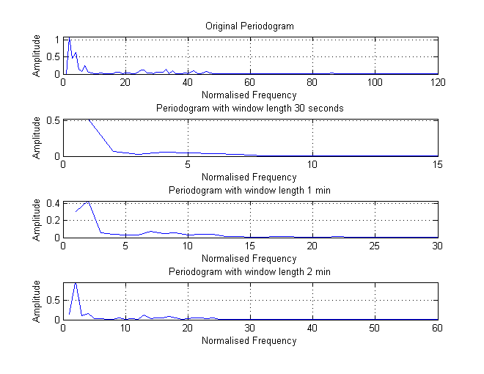**3.4 Real world signals: Respiratory sinus arrhythmia from RR-Intervals**

**Figure 14.** Periodograms of RRI, trial 1

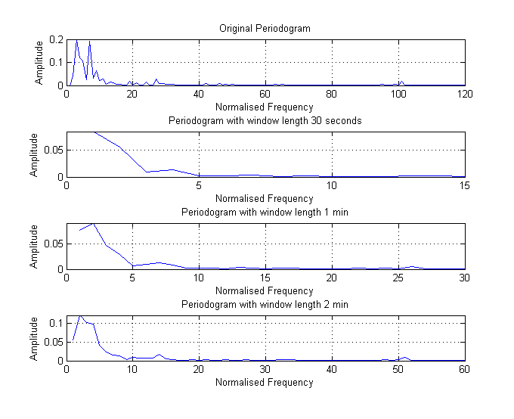

**Figure 15.** Periodograms of RRI, trial 2

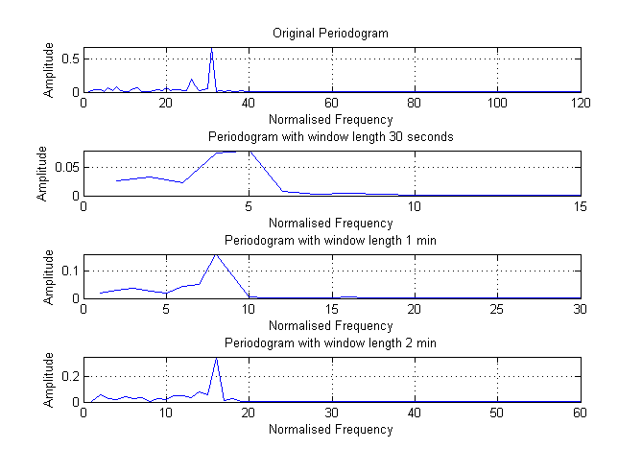

**Figure 16.** Periodograms of RRI, trial 3

Figure 14, 15 and 16 show the periodogram of RRI for different trials using different estimation parameters. It is observed that estimates of RRI from three trials have different peak frequency, regardless of estimation window length. Their valid frequencies are at 40 Hz, 100 Hz and 30 Hz correspondingly. The averaged data gives us more information about which peak is valid. Trial 2 has the highest peak frequency meaning that RRI changes more rapidly. Trial 3 has the lowest peak frequency, meaning that RRI changes very slowly. The peak in trial 1 at 40 Hz means there are 40 cycles of respiration, i.e. 20 beats per minute, which is around the expected frequency of natural breathe. So corresponding RSA is $20×2÷60=0.667$. Similarly, RSA of trial 2 and 3 are approximately 1.667 and 0.125.

If we zoom in the graph, we observe harmonics at higher frequencies. For example, in trial, there is a peak at 200 Hz, which is essentially a harmonic of the major peak at 100 Hz.